February 2014 Junior Infants
Hello everyone, welcome to wet February. This month was a busy one. We learned about St. Bridget and spring, Irish legends Oisín and Tir na nÓg, and loud and soft sounds.
In Maths, we learned value of numbers, and what’s bigger and smaller than certain numbers.
We would like to wish the Ardrahan Senior Camogie team all the very best in the All Ireland in Croke Park on Sunday March the 2nd. We drew pictures and decorated slogans to support the team, we’re all behind you!
Our Write- a- Books are coming along brilliantly, we are nearly finished them and will have pictures here of the published books next month.
Ms. O Doherty is on an EPV day on Friday the 28TH of February.
Happy birthday this month to three girls in our room who all, remarkably have the same birthday- they are Ellie, Béibhinn and Tara. The chair got plenty of spins that day!
We brought teddy in to school for Art this month. We used our teddies as inspiration to draw an oil pastel portrait. Here are our masterpieces!
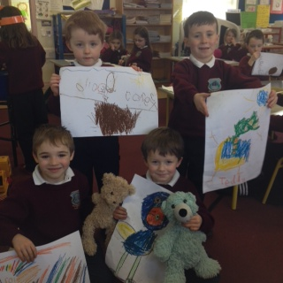

February 2014 Senior Infants
Spring has sprung in Senior Infants! We’re looking forward to the rain stopping so we can go on the grass again; it’s been a long time!
In Maths, we learned value of numbers, and play games to find out what numbers are squashed between numbers teacher calls out.
Our Write- a- Books are coming along brilliantly, we are nearly finished them and will have pictures here of the published books next month.
We would like to wish the Ardrahan Senior Camogie team all the very best in the All Ireland in Croke Park on Sunday March the 2nd. We drew pictures and decorated slogans to support the team, we’re all behind you!
Ms. O Doherty is on an EPV day on Friday the 28TH of February.
Happy birthday this month to three girls in our room who all, remarkably have the same birthday- they are Ellie, Béibhinn and Tara. The chair got plenty of spins that day! Ellie and Béibhinn are both six and had a really great birthday party. They got to do magic!
We brought teddy in to school for Art this month. We used our teddies as inspiration to draw an oil pastel portrait. Here are our masterpieces! 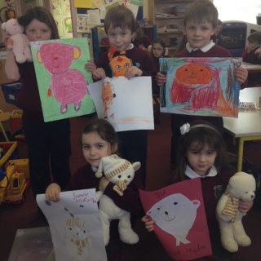 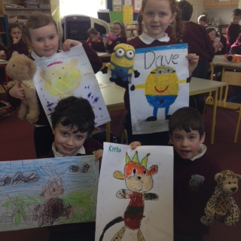
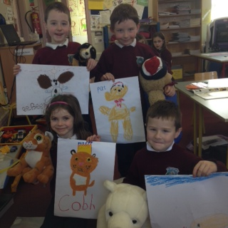
February 2014 First Class
Welcome to spring in First Class. We are learning all about seasonal change in Geography even though some of the days this month looked more like winter than spring!
In Maths, we are learning all about the hundred square and place value from 1-99. We can now regroup and rename tens and units, woohoo!
Our Write- a- Books are nearly finished. Thanks so much to all the mums, dads, brothers, sisters, aunties, uncles, grannies, granddads and teachers who have helped in this massive project. We will have pictures here of the published books next month.
We would like to wish the Ardrahan Senior Camogie team all the very best in the All Ireland in Croke Park on Sunday March the 2nd. We drew pictures and decorated slogans to support the team, we’re all behind you!
Ms. O Doherty is on an EPV day on Friday the 28TH of February.
Happy birthday this month to three girls in our room who all, remarkably have the same birthday- they are Ellie, Béibhinn and Tara. The chair got plenty of spins that day! Tara is the granny of the group at seven years old. She got her ears pierced for the occasion, fancy!
We brought teddy in to school for Art this month. We used our teddies as inspiration to draw an oil pastel portrait. Here are our masterpieces!

